|  |  |  |  |  |  |
| --- | --- | --- | --- | --- | --- |
| Date | 9-Dec-22 | | | Tester Name | Janette Paus |
| Environment | Penfax - Test 2 | | | Login used | <If different from the Tester> |
| Operating System | Windows | Version: 21H2 | Update Number: | | |
| Software Used | Select Software | Version: 107.0.1418.56 | Update Number: | | |
| Select Software | Version: | Update Number: | | |
| Application Release version | R22.4.1 | | | | |
| Test Case Title | E20.05b | | | | |
| Test Type | Regression | | | | |
| Test Scenario | Reverse a Lump Sum Payment (completed on PENWEB) | | | | |
| Expected Results | To reverse a lump sum that was completed on PENWEB by a member. Expect for payments with tax, the taxes will also be reversed and the units to be re-deposited into the member’s account. The breakage entries are reasonable. | | | | |
| Pass/Fail | Select | | | JIRA# | <enter the new JIRA ticket number if the test case failed> |

Find a payment in Batches/Payment production, hit search and find a payment that was processed online

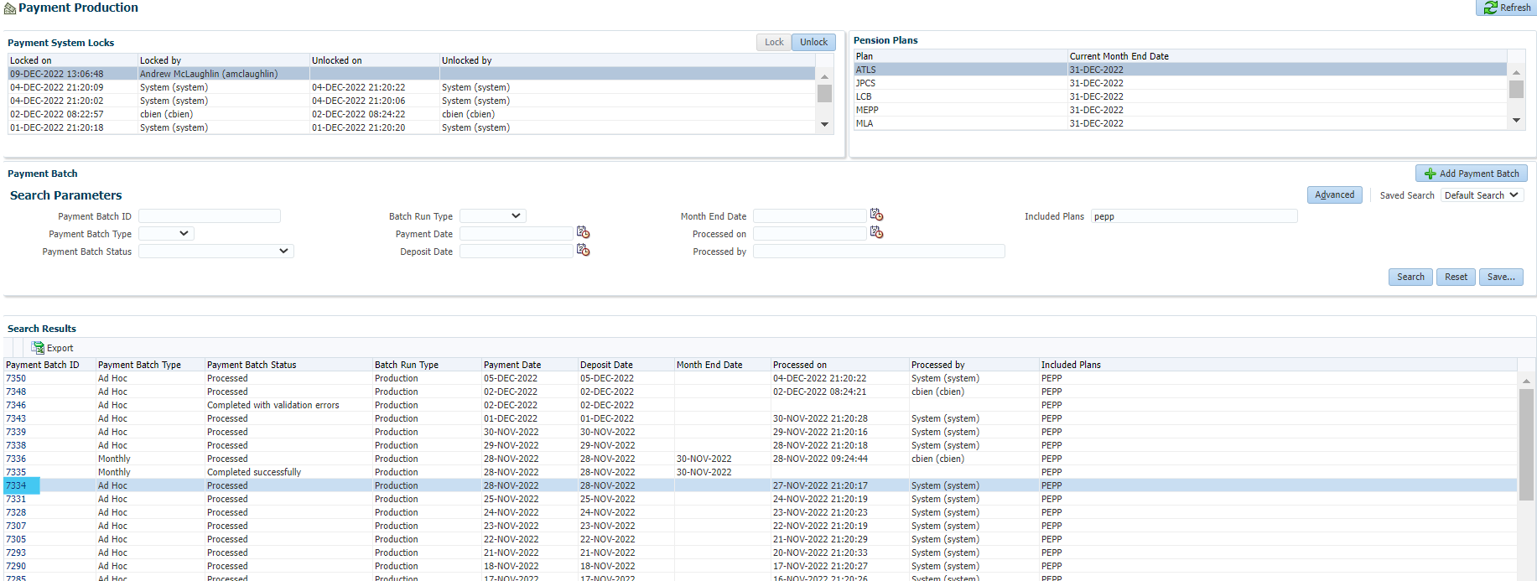

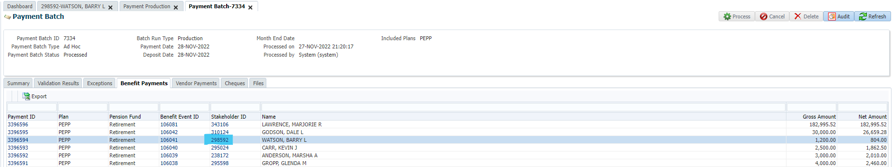

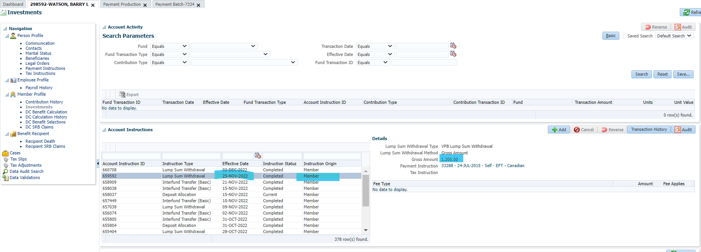

Reverse Lump Sum & taxes (processed on PlaNet)

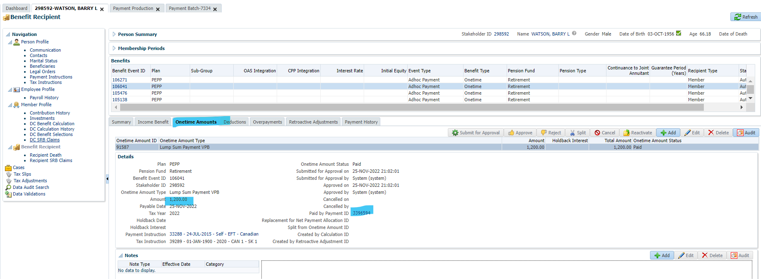

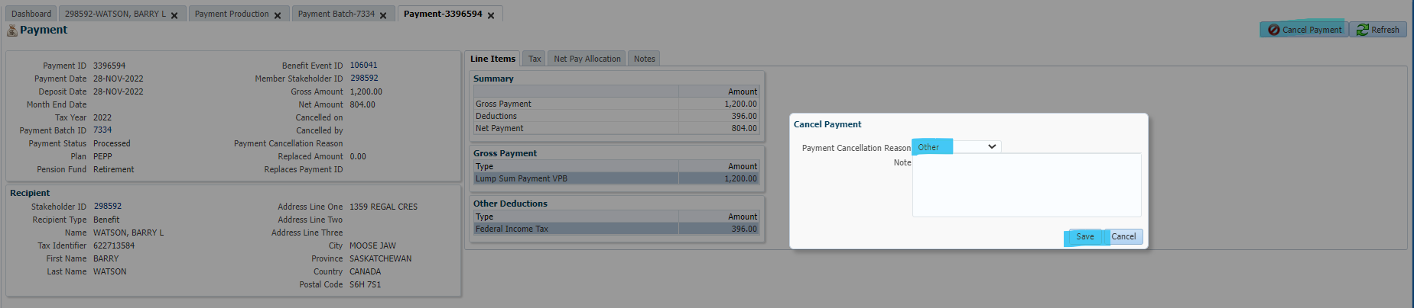

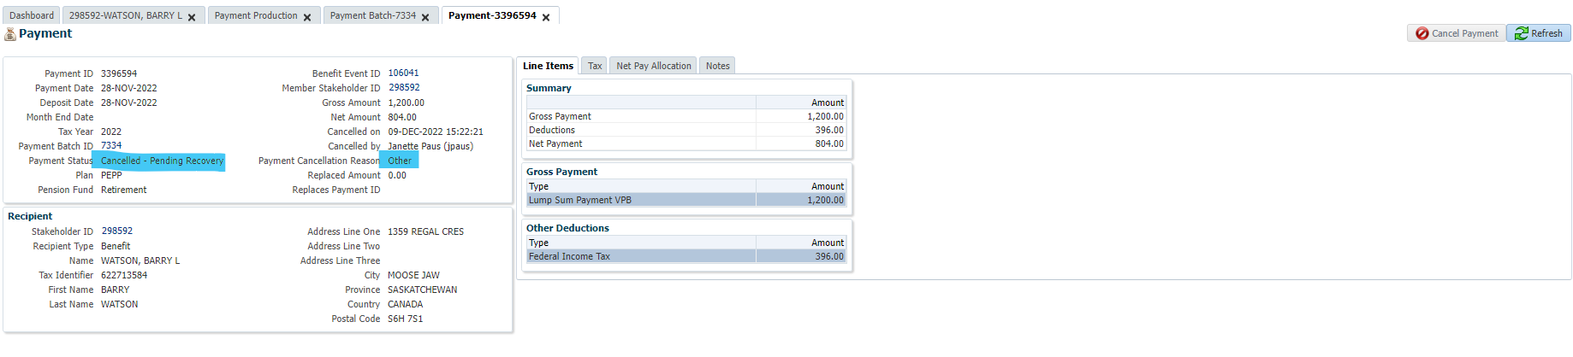

Benefit recipient, overpayments, expand recoveries and click add (for each of the line items):

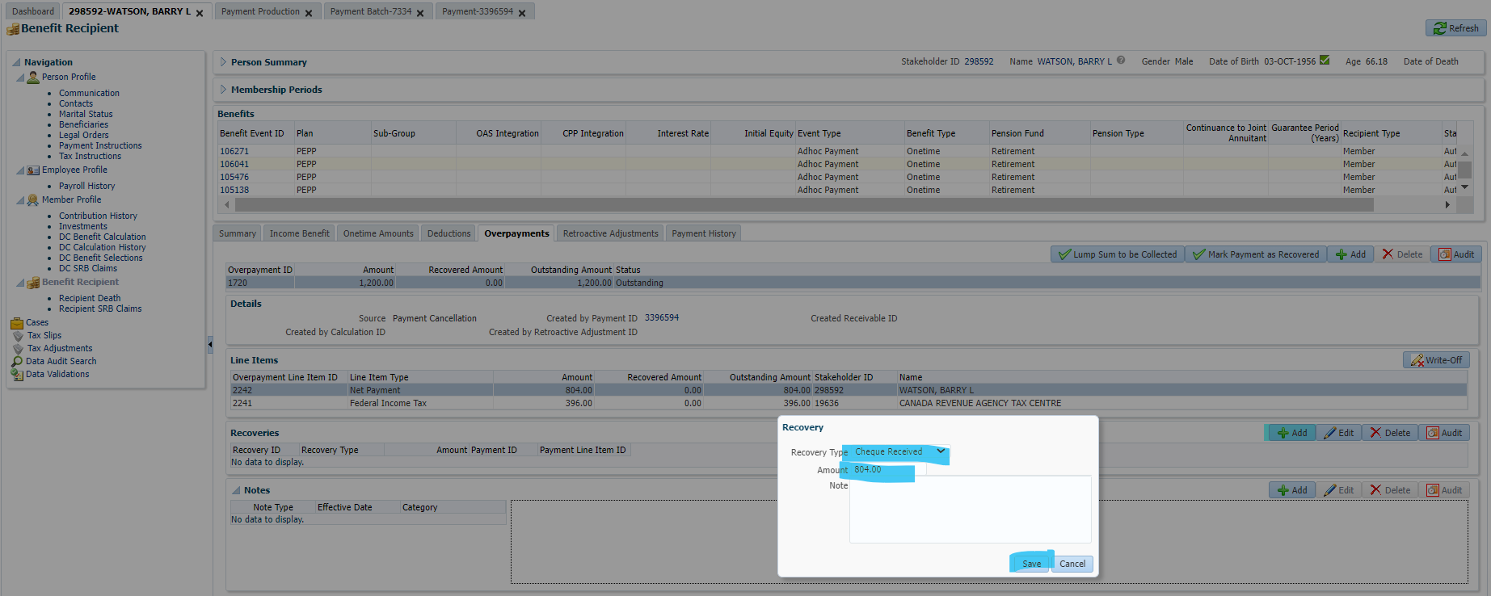

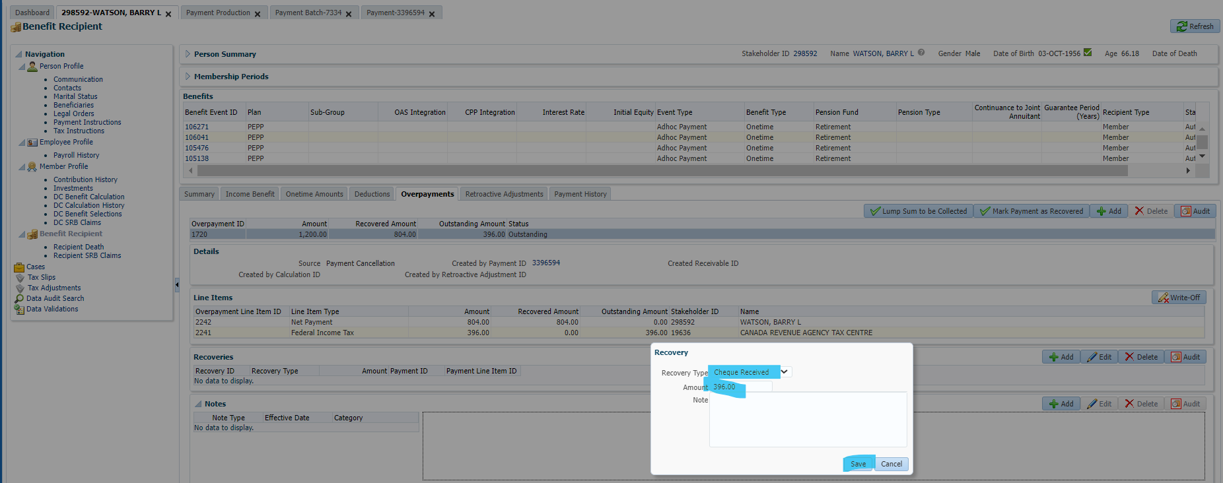

Click mark payment as recovered and Save.

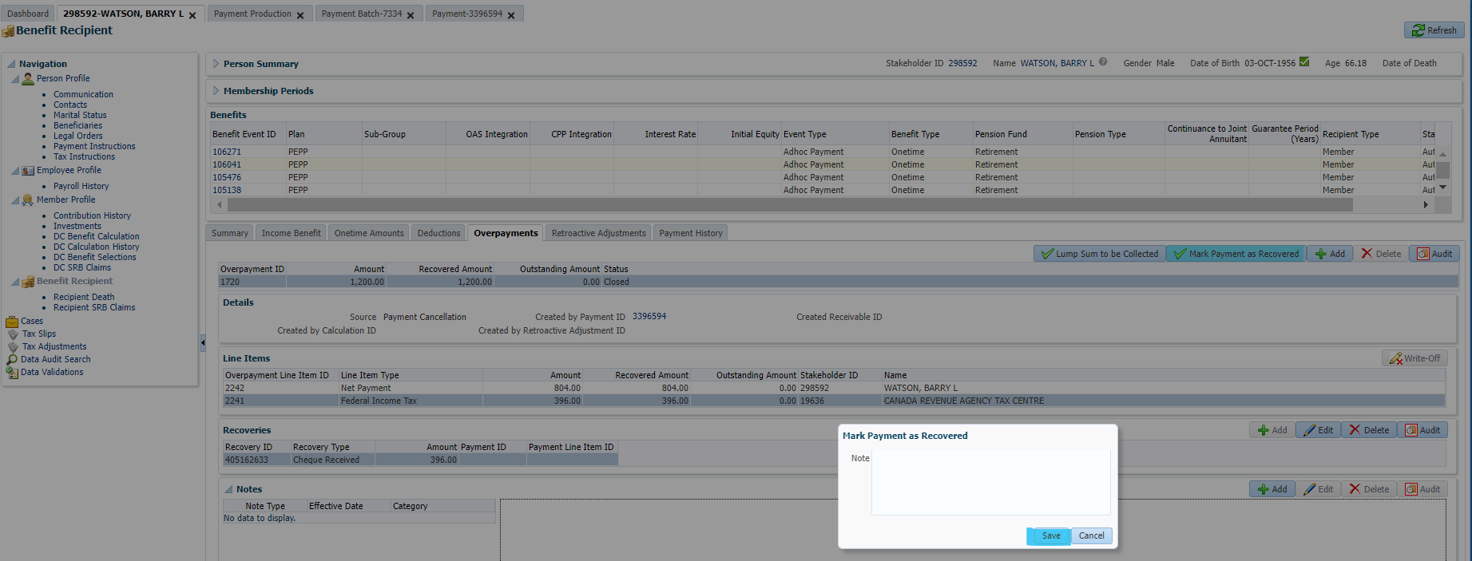

Go to investments/account activity and reverse the payment:

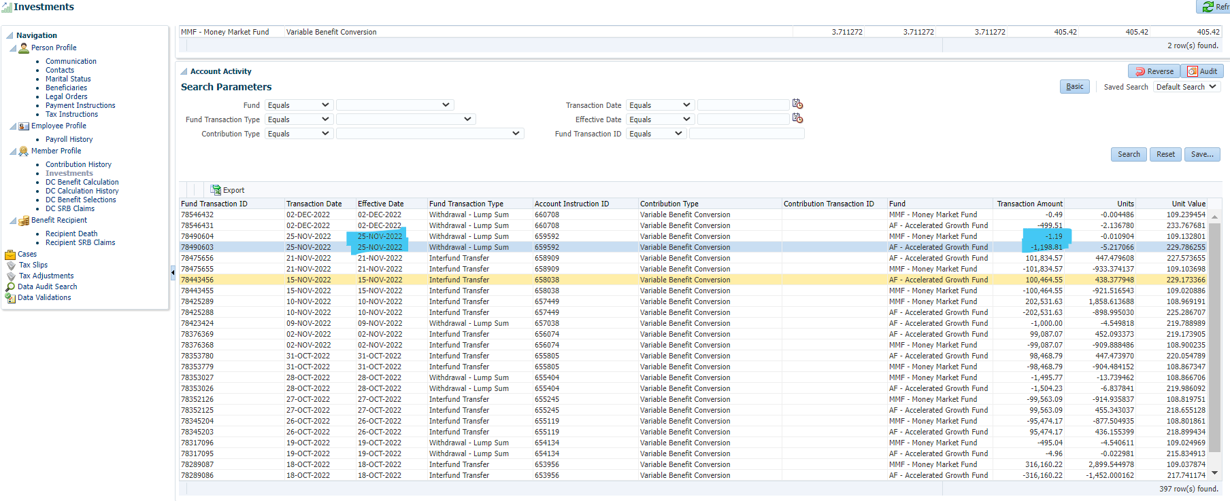

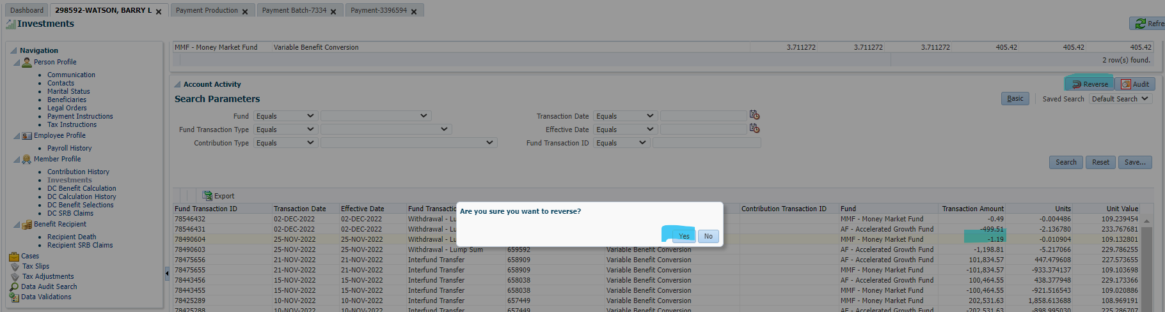

Got this error: unable to reverse, try under investment instructions.

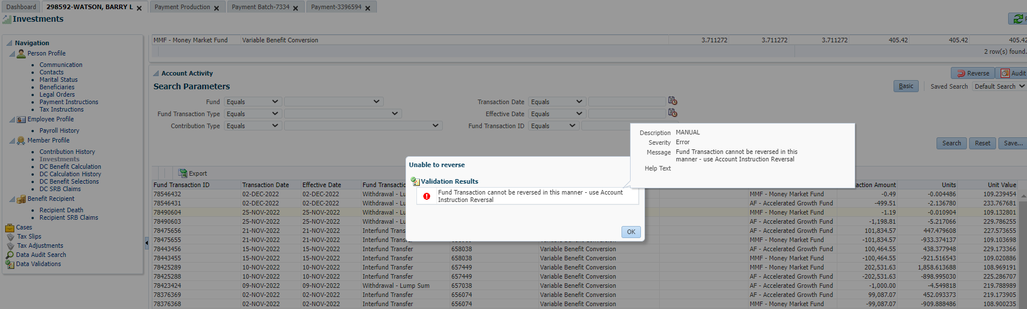

When I go to investment instructions, cancel and reverse are both greyed out:

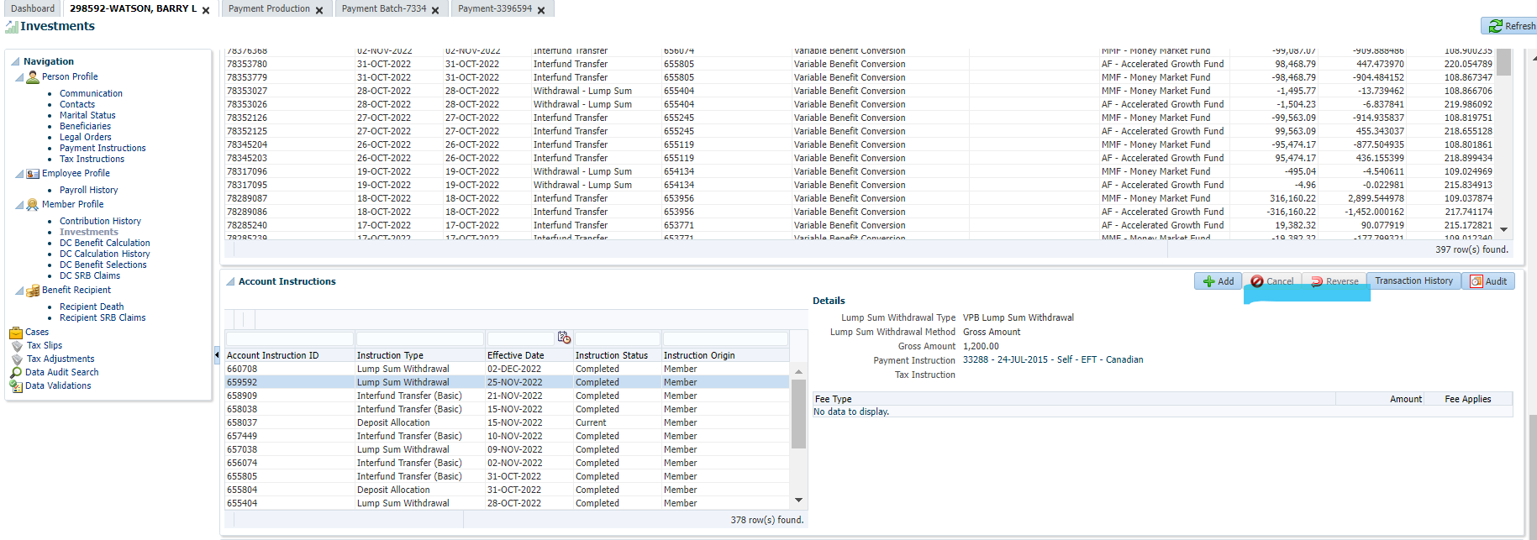

Sonu confirmed it wasn’t a security clearance issue as cancel and reverse are part of our security roles. Confirmed with other users that Cancel/Reverse are greyed out for them.

**We found a work around:**

To make the reverse button appear, you highlight a non-lump sum record (eg. Interfund transfer), then press the add button, and then cancel. That allows the reverse button to appear for all lines under account instructions (non-greyed).

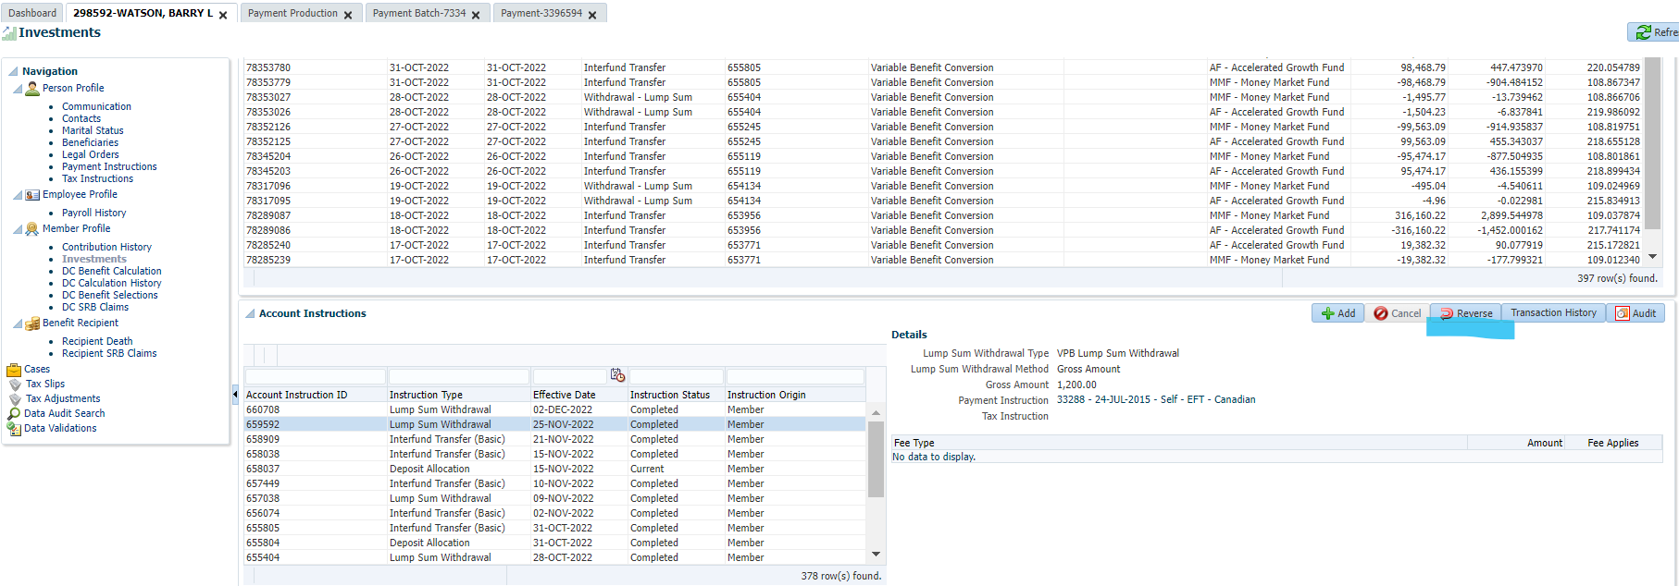

**When processing reversal, issue #2:**

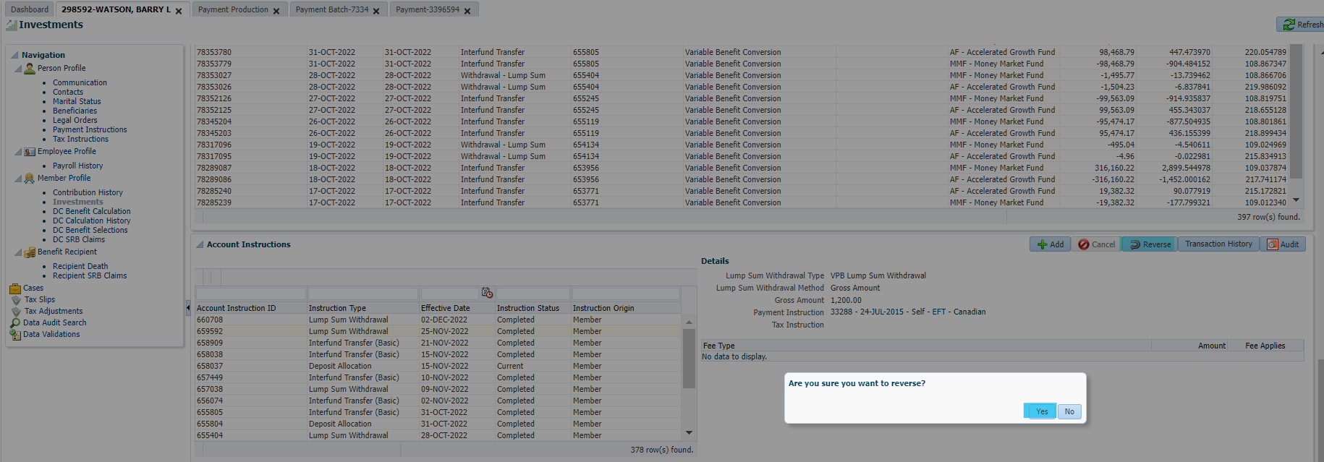

Still get validation Error & unable to reverse the transaction:

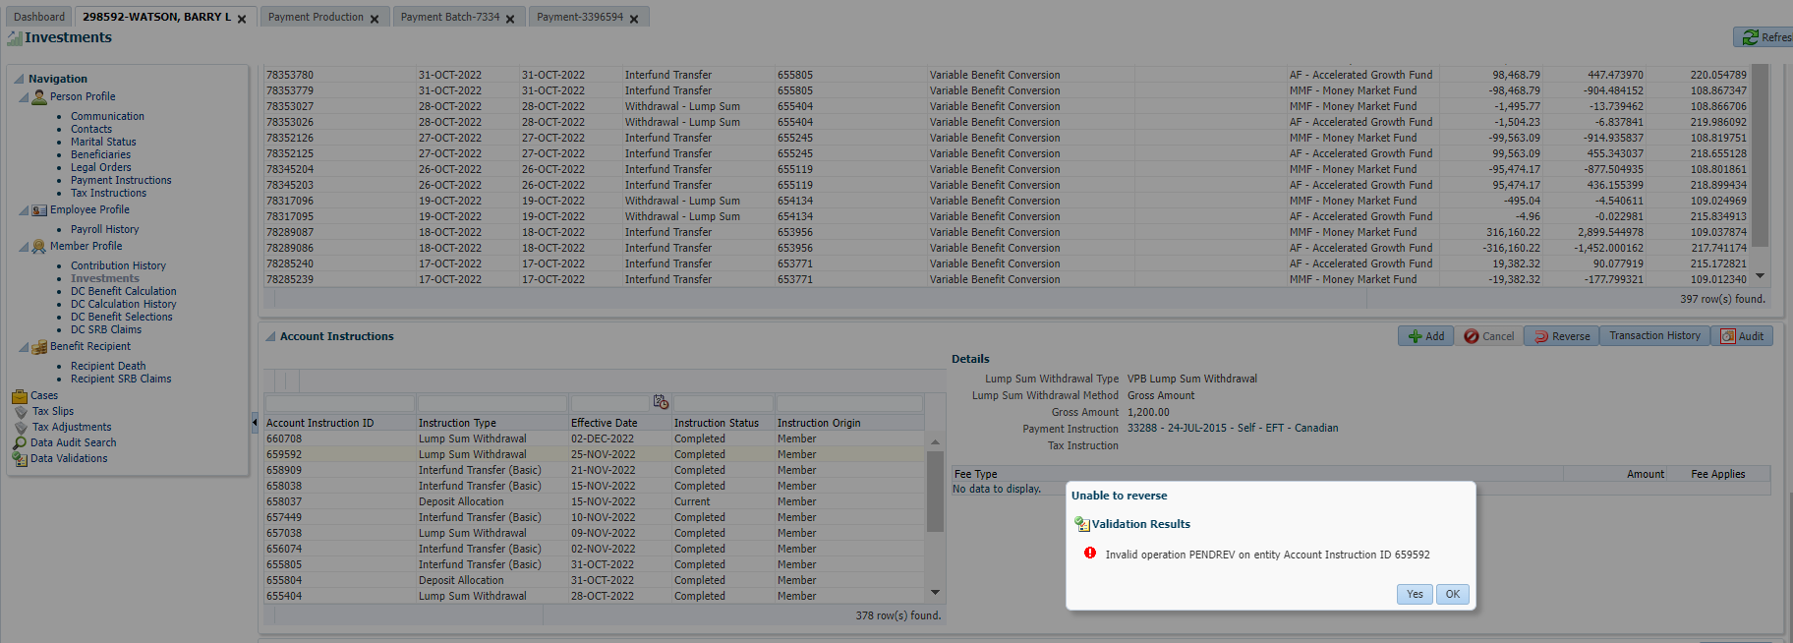

Ticket Submitted & Test Case failed: Appears to be some sort of refresh issue for this transaction in Test 2. Buttons are greyed out & unable to reverse a lump sum processed on PENWEB due to the error as there is no other place to reverse this transaction.